BIT 4107 – Mobile Application Development
ENHANCED PROFESSIONAL STUDENT LOGBOOK
Student Name: yvonne mwende njeru
Admission Number: _BIT/2024/60085
School/Faculty: science
Programme : degree
Academic Year: 2024
Semester: 3
Lecturer: Michael Nyoro
Phone Number: 0799995976

Table of Contents
1.0 Week 1: Introduction to Mobile Application Development 3
1.1 Practical Activities Undertaken 3
1.2 Tools/Software Used 3
1.3 Personal Reflection 3
2.0 Week 2: Mobile Development Environment 4
Week 3: User Interface Design 5
4.0 Week 4: Event Handling and User Interaction 5
5.0 Week 5: Data Management 10
6.0 Week 6: Networking and APIs 12
7.0 Week 7: Application Architecture 13
Week 8: Project Planning 15
Week 9: Device Features and Sensors Error! Bookmark not defined.
Week 10: Notifications and Background Services Error! Bookmark not defined.
Week 11: Mobile Security Error! Bookmark not defined.
Week 12: Testing and Debugging Error! Bookmark not defined.
Week 13: Application Deployment Error! Bookmark not defined.
Week 14: Final Project Presentation Error! Bookmark not defined.
Semester Project Tracking Error! Bookmark not defined.
End of Semester Reflection Error! Bookmark not defined.
Final Approval Error! Bookmark not defined.

1.0 Week 1: Introduction to Mobile Application Development

1.1 Practical Activities Undertaken
Flutter mobile application project structure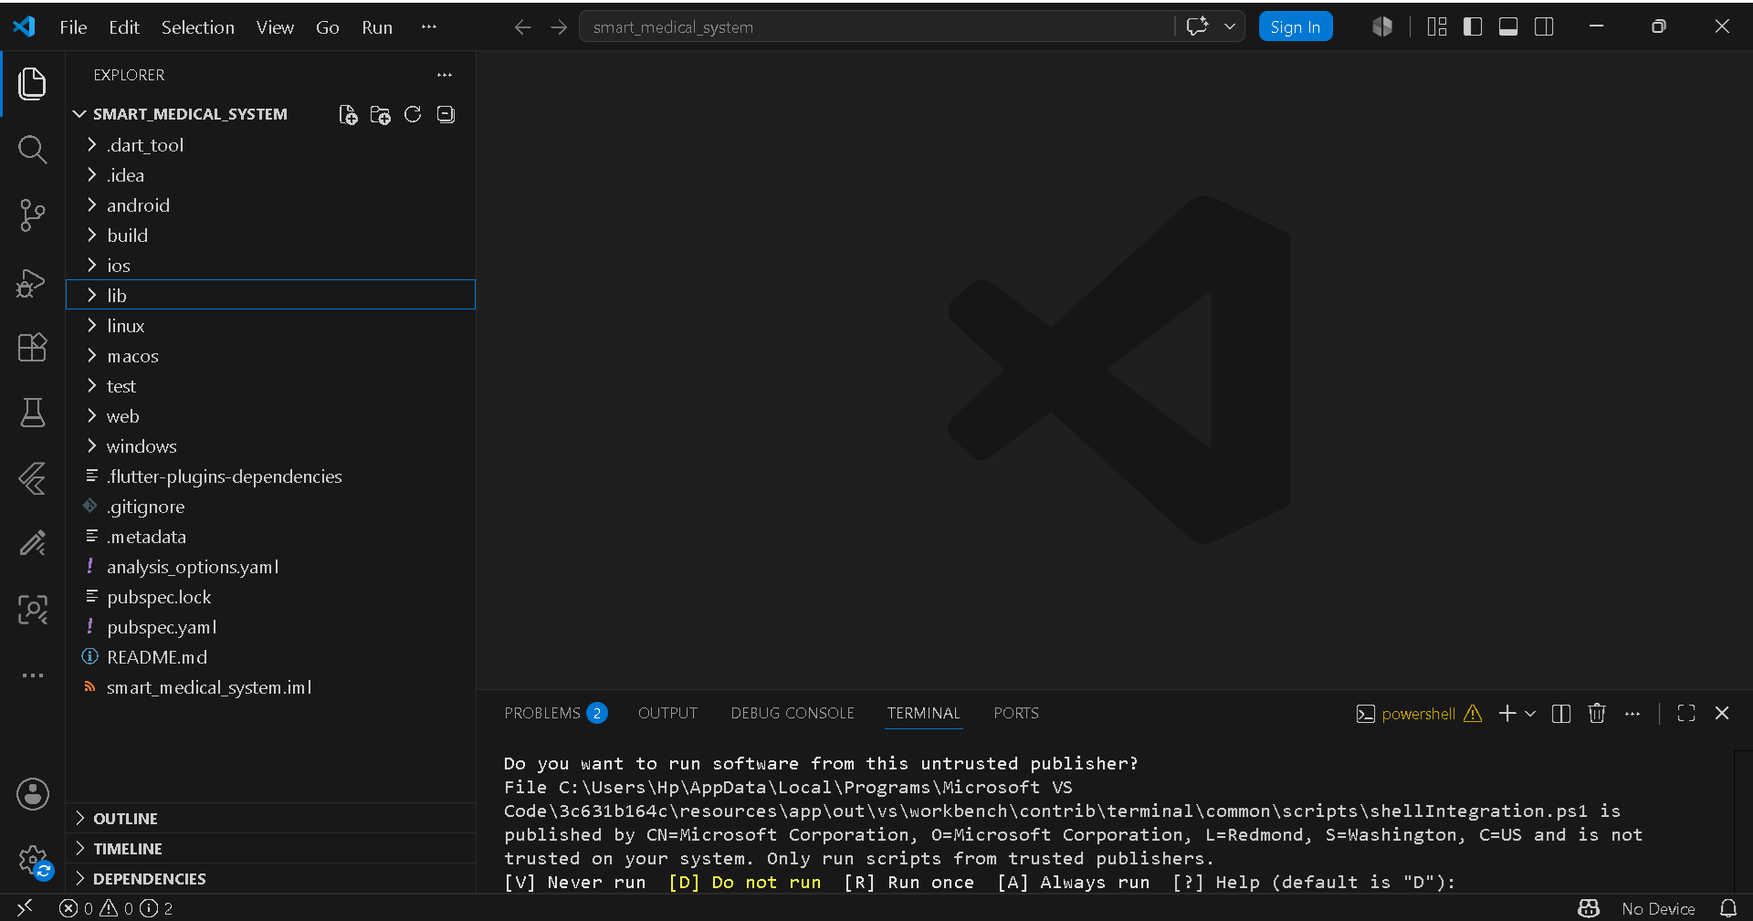

1.2 Tools/Software Used
- Flutter
- VS Code
- Android Studio

Personal Reflection
I learned how to create a Flutter mobile application project structure and understand the main folders required for development.

2.0 Week 2: Mobile Development Environment
Flutter development environment configuration
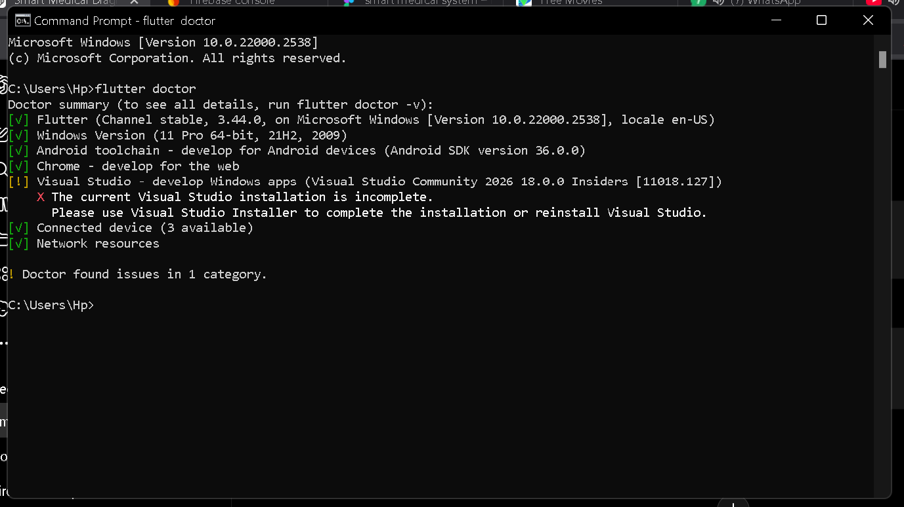

Personal Reflection
I learned how to configure a mobile development environment and connect Flutter with an Android emulator. I gained knowledge on troubleshooting setup issues and ensuring the development tools work correctly.

3.0 Week 3: User Interface Design
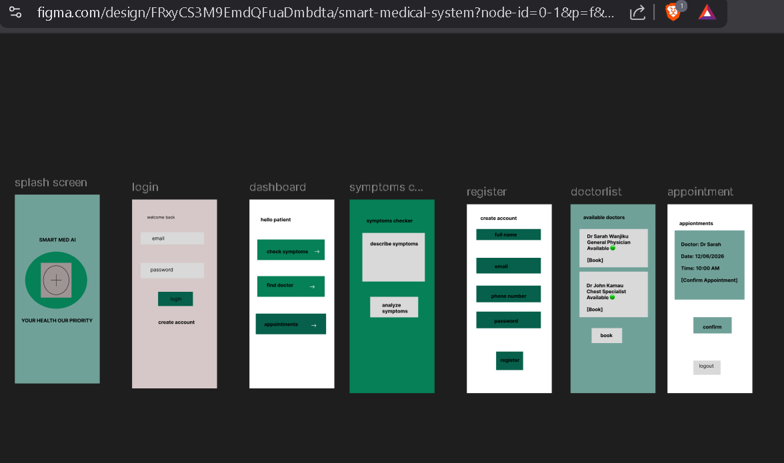

Personal Reflection
I learned how to design user interfaces before implementation. I understood the importance of creating simple and user-friendly layouts that improve user interaction and experience.

4.0 Week 4: Event Handling and User Interaction

Personal Reflection
I learned how Flutter widgets are used to build mobile interfaces. I improved my understanding of screen navigation and creating interactive components for better user experience.

4.1Login page

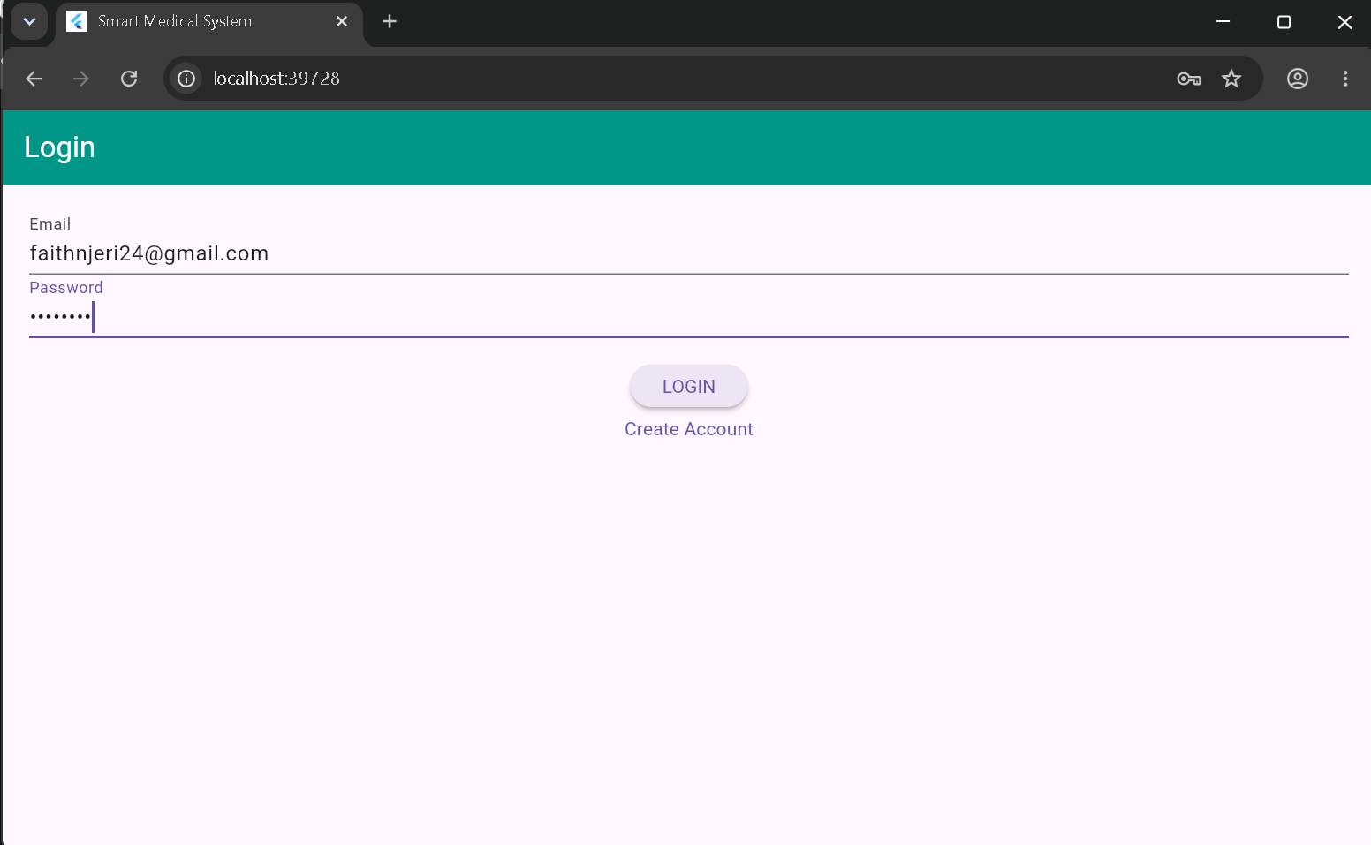
4.2 dashboard page

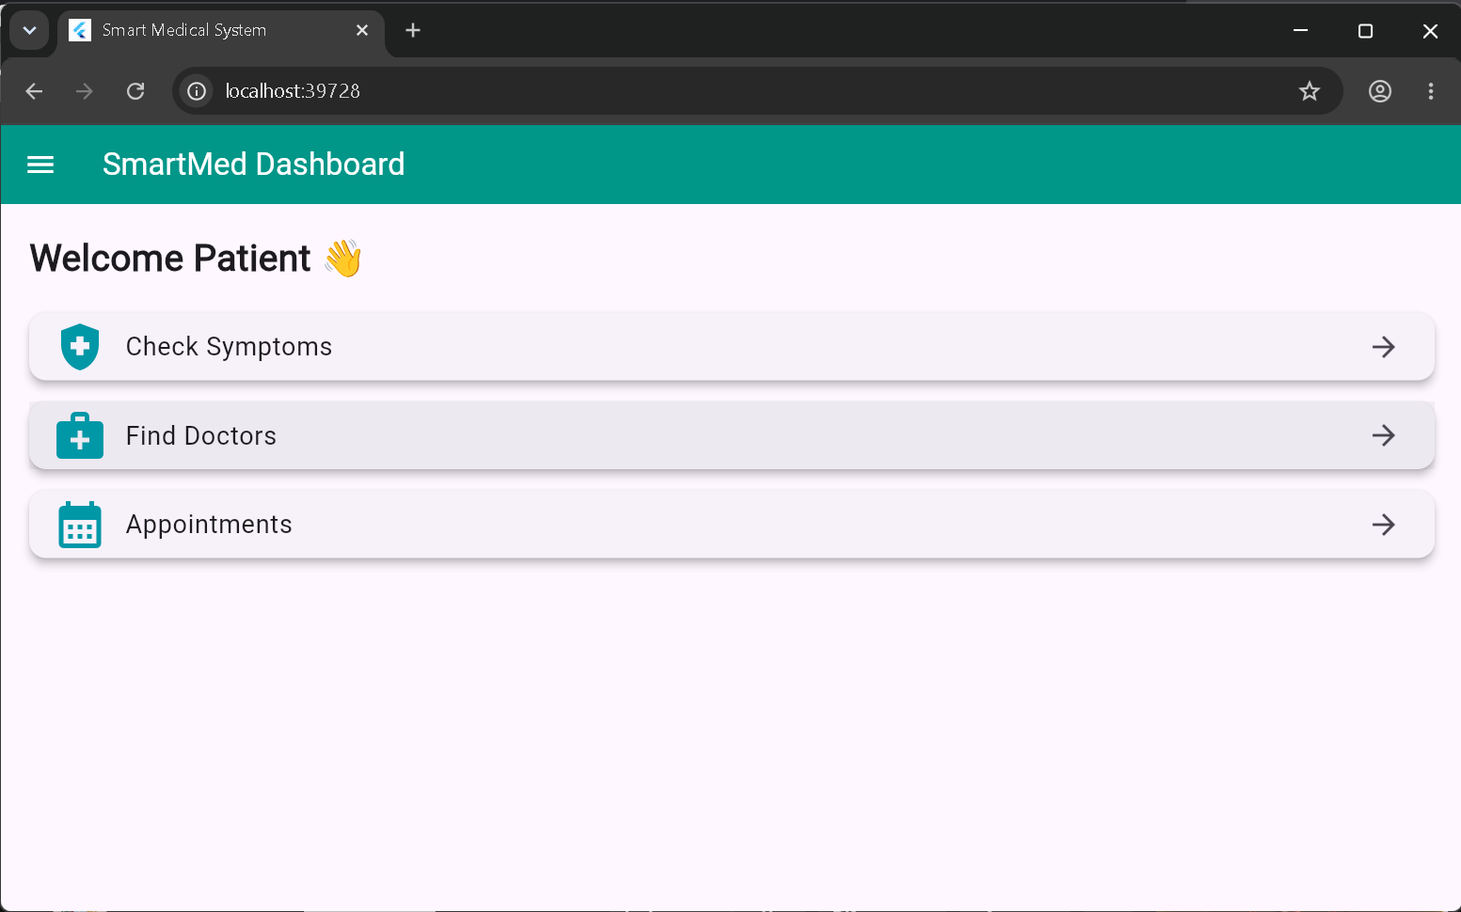

4.3 Symptom checker

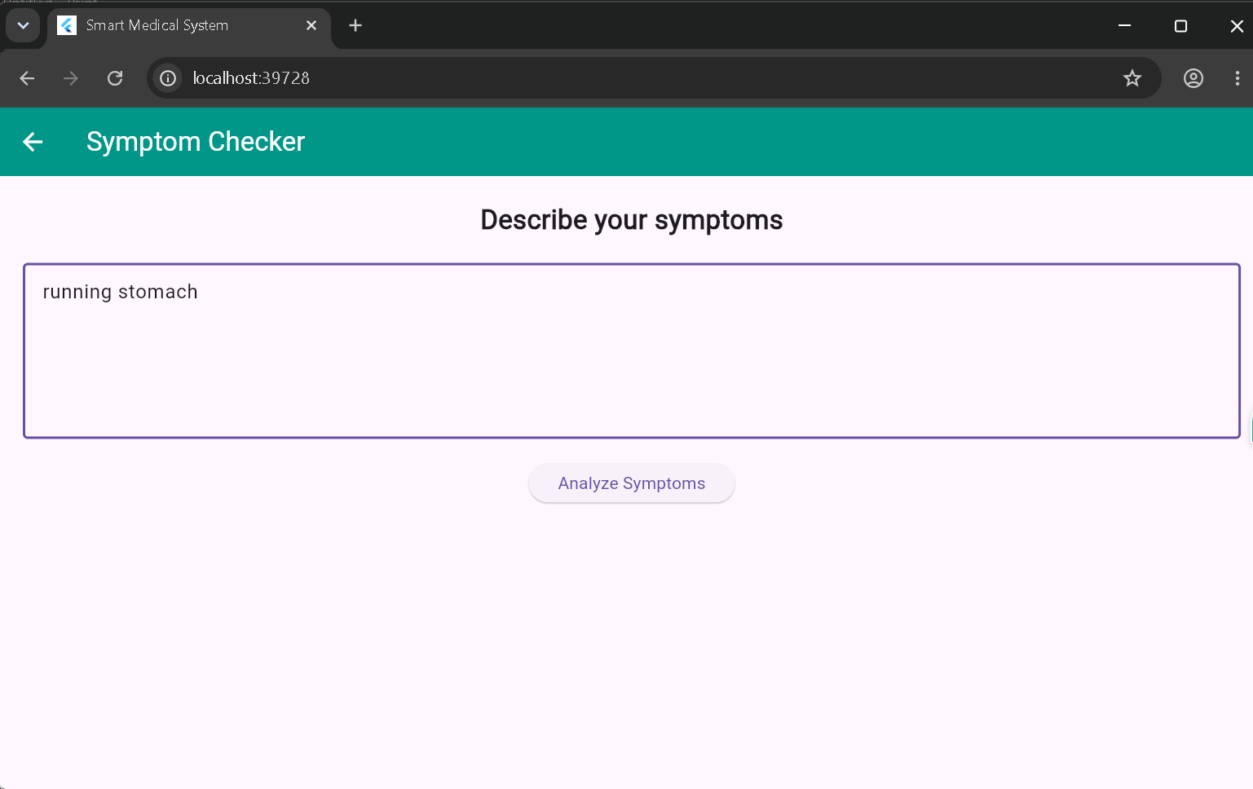
4.4 results diagnosis
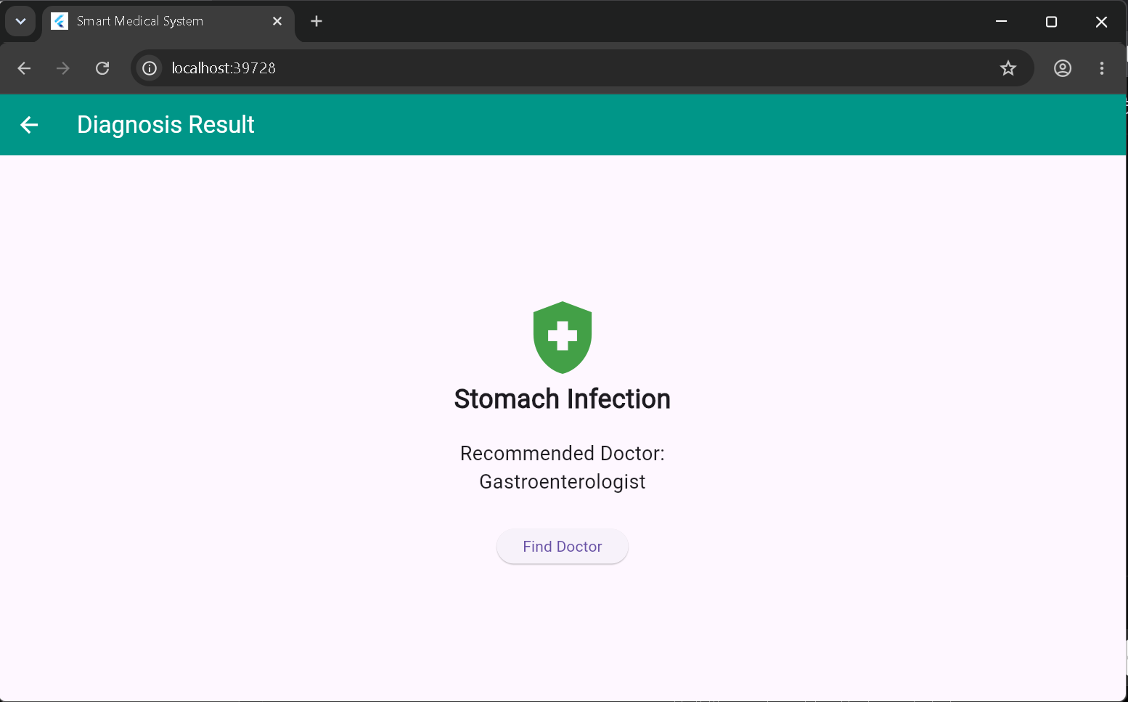

4.5 doctors available
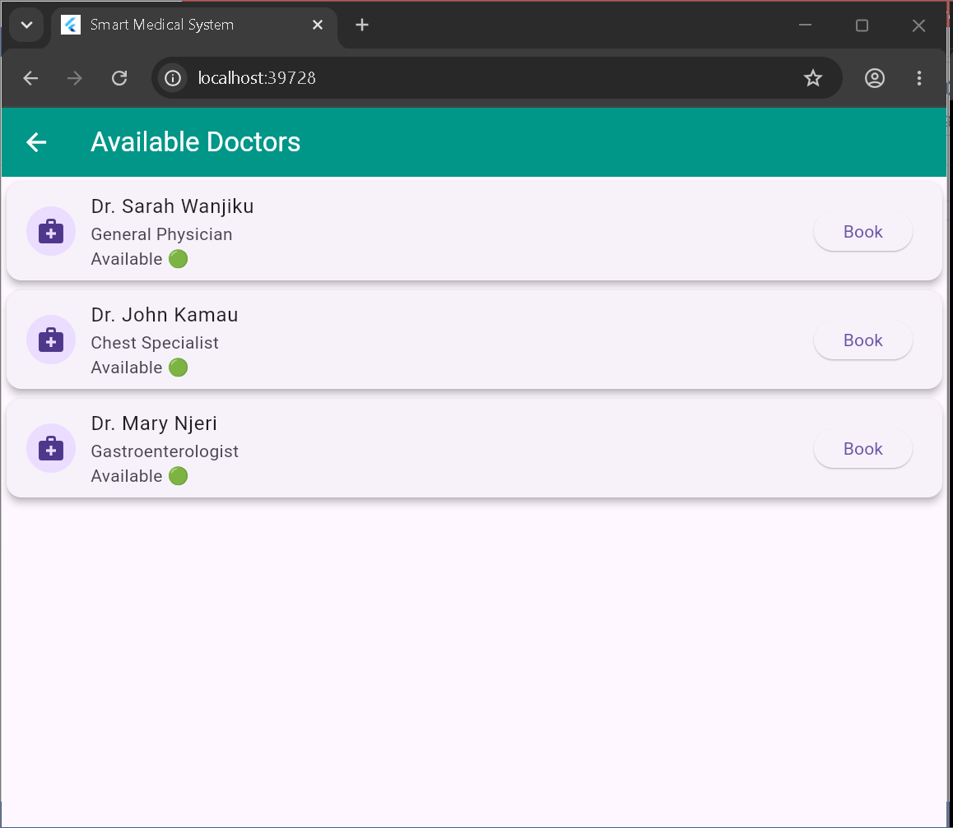
4.6 booking appointment
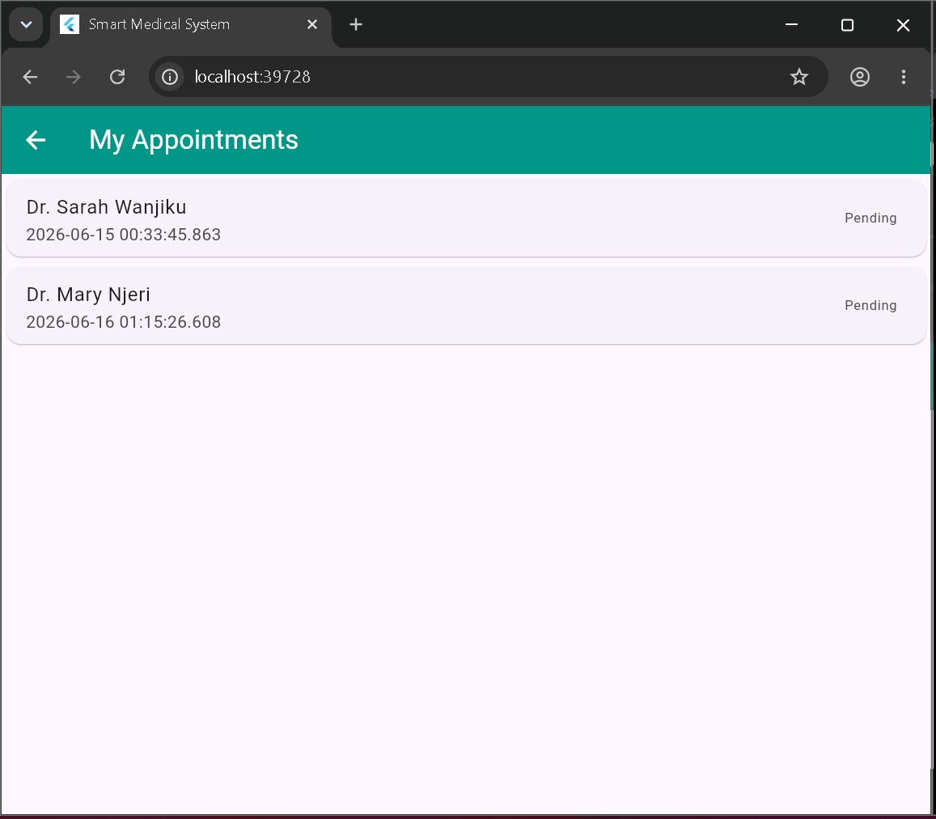
4.7 pending appointments

4.8 logout
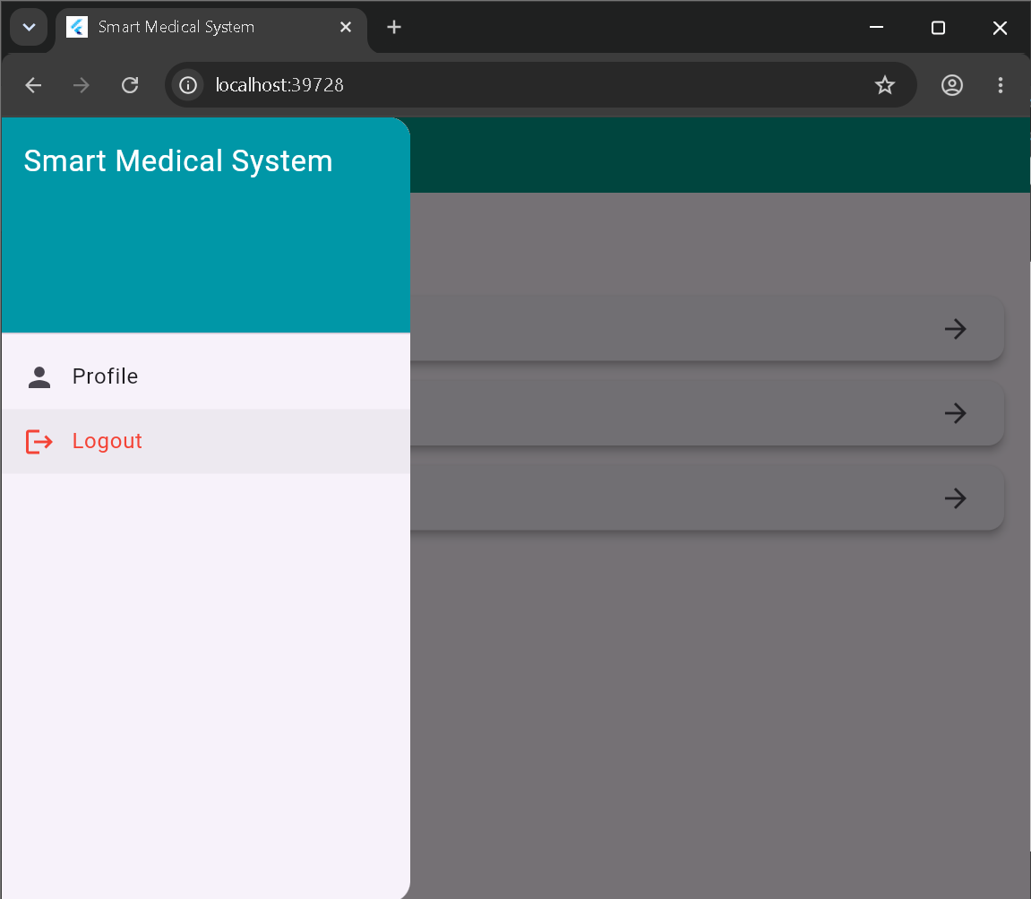

5.0 Week 5: Data Management
5.1Firestore Database
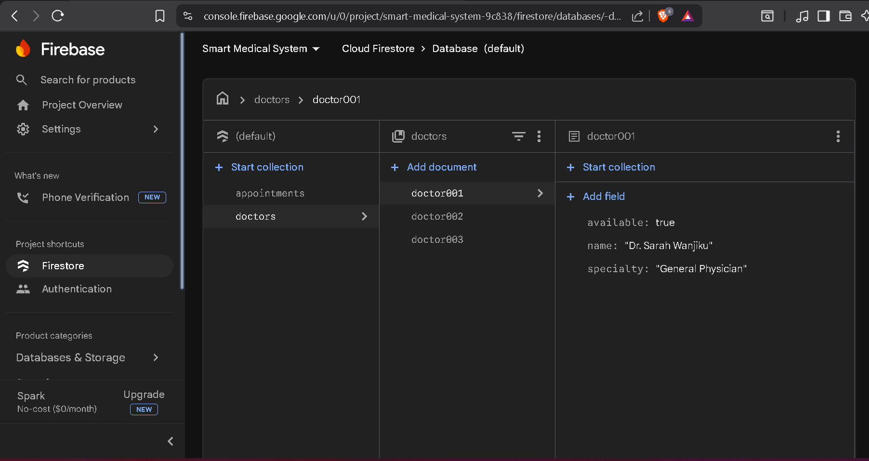
5.2 Firestore Database
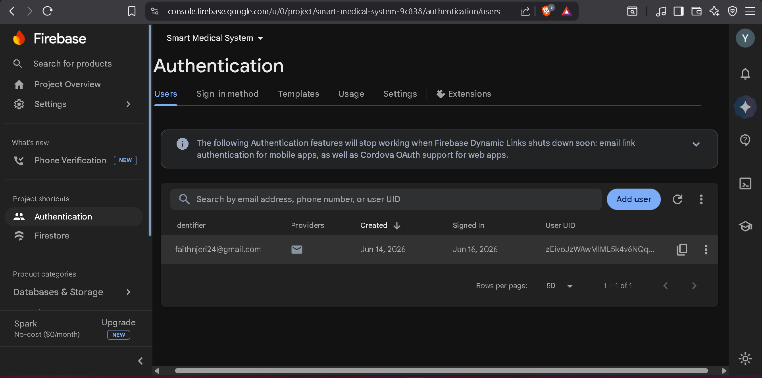

5.3 Firebase Firestore database collections
Doctors record

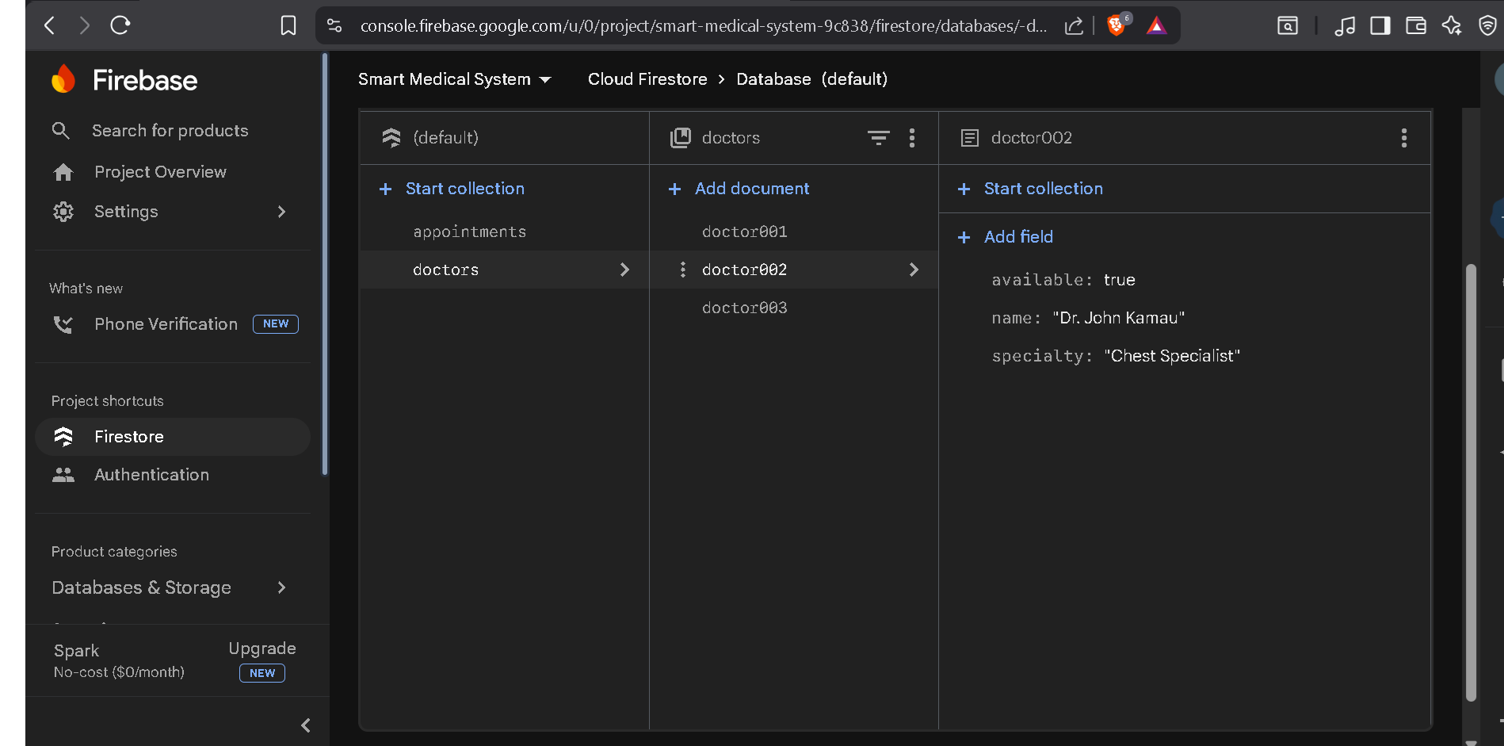

Personal Reflection
I learned how cloud databases support mobile applications. I understood how Firebase stores user, doctor, and appointment information and how applications communicate with online databases.

6.0 Week 6: Networking and APIs
6.1Firebase API initialization code
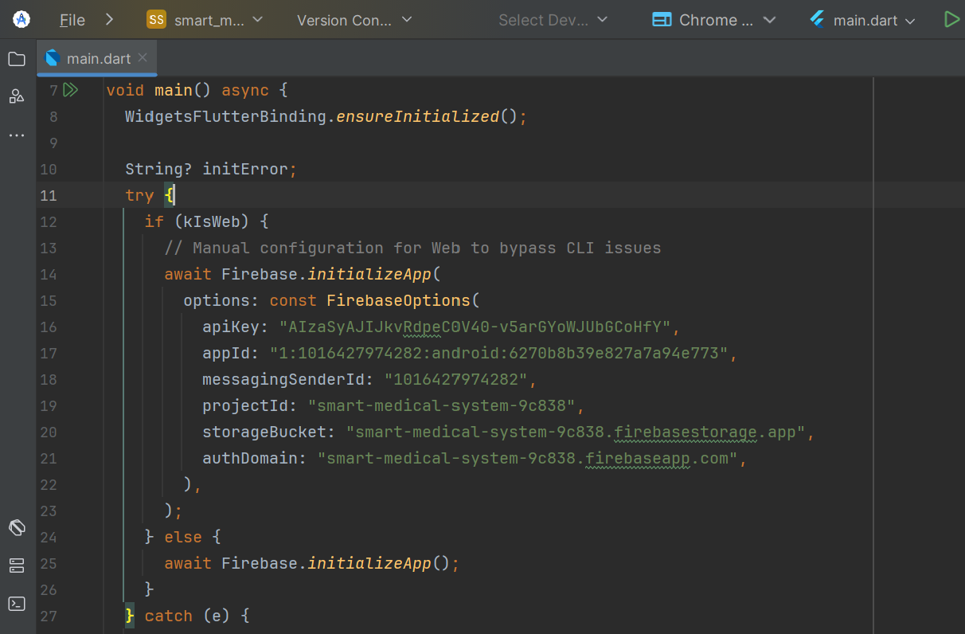
6.2 Internet permission configuration for API communication
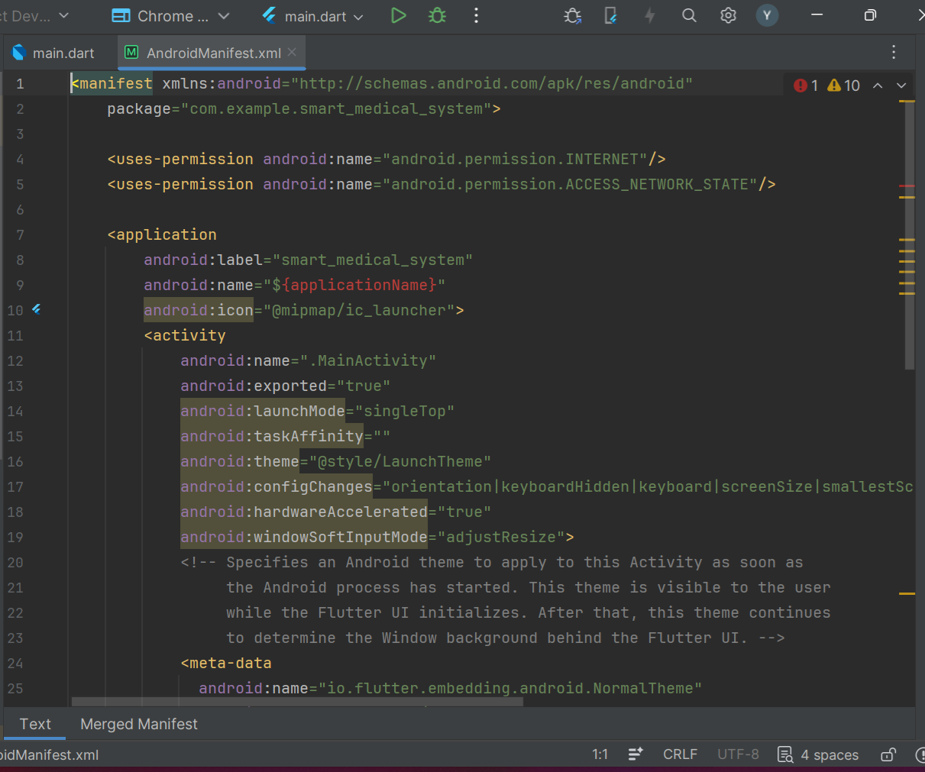

6.3Internet permission configuration for API communication
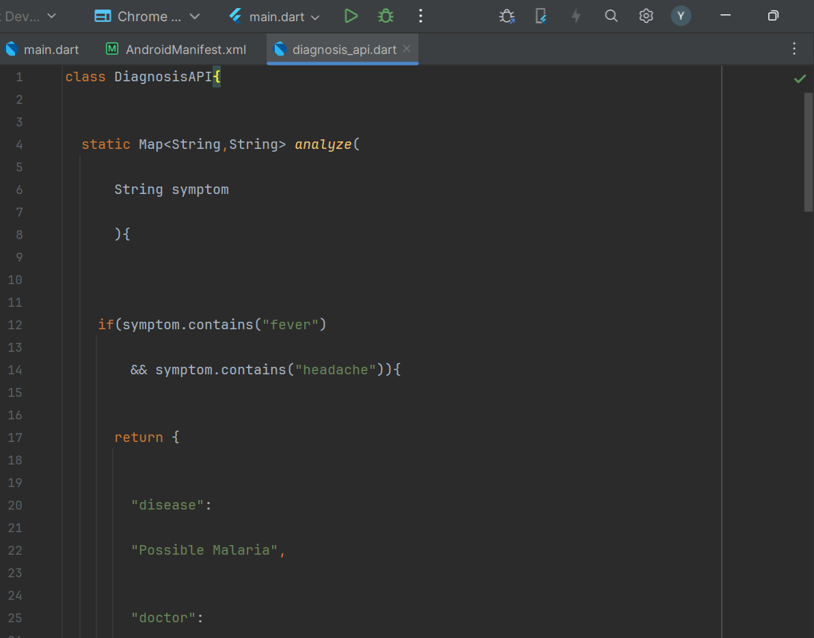
Personal Reflection
I learned how mobile applications communicate with external services through APIs. I gained knowledge on configuring network permissions and connecting application features with online resources.

7.0 Week 7: Application Architecture
7.1 Flutter application architecture structure
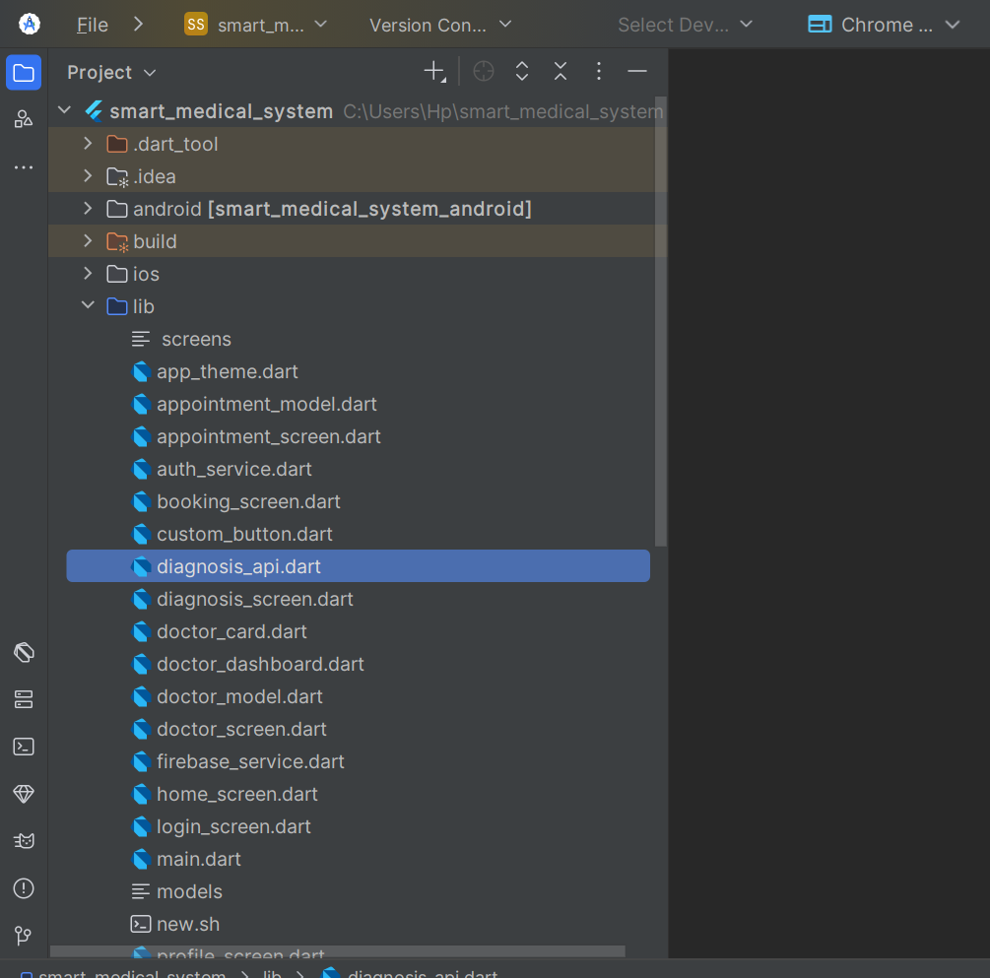
Personal Reflection
I learned the importance of organizing application code properly. Separating files into different sections improves maintenance, debugging, and future system expansion.

8.0 Week 8: Handling User Input and Events
8.1 User input fields implemented in Flutter login interface
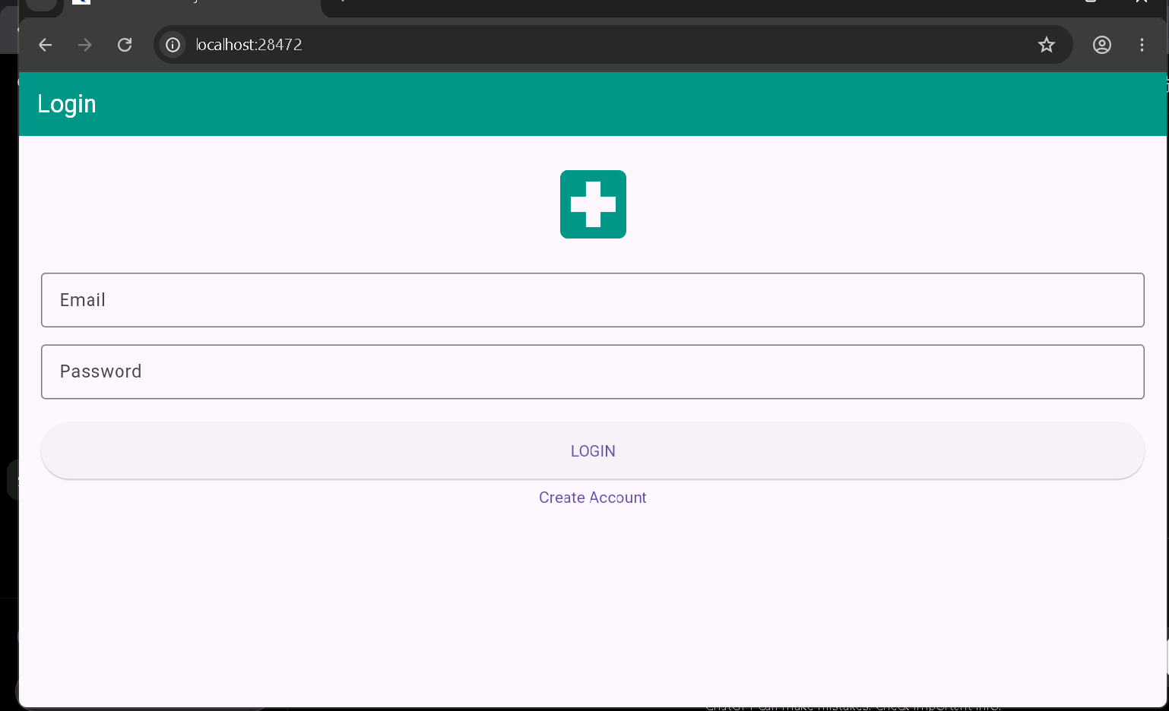
8.2 Symptom input handling interface

8.3 Button event handling and system response


Practical Activities Undertaken
Implemented user input handling in the Smart Medical Diagnosis and Doctor Allocation System. Added text field inputs, button click events, navigation between screens, and validation to ensure correct user interaction with the application.
Personal Reflection
I learned how mobile applications respond to user actions through event handling. I gained knowledge on implementing text input, button events, and validation in Flutter, which improved the interactivity and usability of the healthcare application.

9.0 Week 9: device feature integration, specifically Camera and GPS
Camera integration showing how to capture symptom image.
By uploading a photo it automatically gets analyzes and gives results
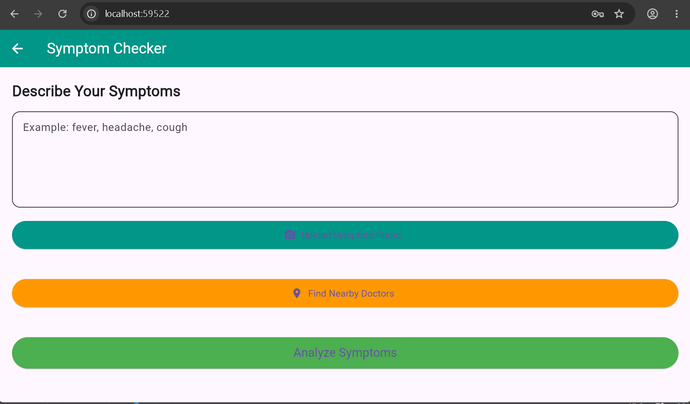

GPS integration displaying the user's current location
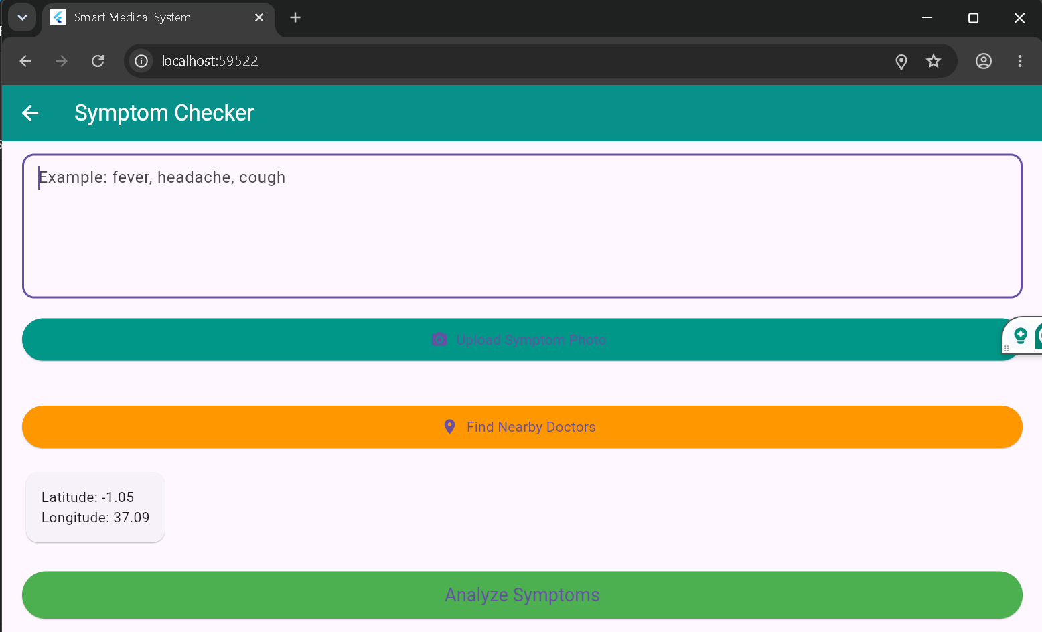
I learned how to integrate smartphone features such as the camera and GPS into a Flutter application. I also understood the importance of requesting runtime permissions and using location services to improve healthcare accessibility and enhance the user experience.

